

We are absolutely thrilled you are interested to join us at Rohlik Group. By now we have spoken to you about your experience and personality in great detail. Next step is to find out how you tackle a task in reality.

**How to build a mechanism?**

**Situation**

Please decribe a mechanism that you implemented into operations. Please briefly decribe the situation, your task in the implementation, the actions you took and the result. For structure please use the follwing apporach.

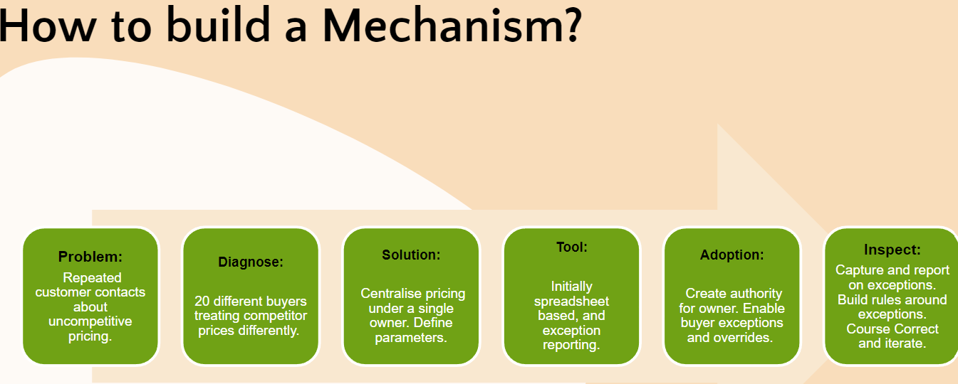

**Format**

Result of the case study should be captured in a format of your choice that is easily shareable with us during the next meeting in English. We don’t need you to write essays, clear and consistent content is much more important to us. Please send us the presentation materials of your Case study 1 day prior to the meeting so we can review and get ready for the talk.